JOB TRACKING & MANAGEMENT SYSTEM

**Software Requirements Specification**

**INT 220- Server-Side Scripting**

**Students Name and Registration No.**

**Paras Pathania – 12401142**

**Yash Pandey – 12411469**

**Phaneendra Kakumani – 12418953**

**Rishav Kumar -12400591**

Prepared for Continuous Assessment 2

Spring 2025

# Table of Contents

1. INTRODUCTION 3
   1. Purpose 3
   2. Scope 3
   3. Definitions, Acronyms, and Abbreviations 3
   4. References 3
   5. Overview 3
2. GENERAL DESCRIPTION 4
   1. Product Perspective 4
   2. Product Functions 4
   3. User Characteristics 4
   4. General Constraints 4
   5. Assumptions and Dependencies 4
3. SPECIFIC REQUIREMENTS 5
   1. External Interface Requirements 5
      1. User Interfaces 5
      2. Hardware Interfaces 5
      3. Software Interfaces 5
      4. Communications Interfaces 5
   2. Functional Requirements 5
      1. <Functional Requirement or Feature #1> 5
      2. <Functional Requirement or Feature #2> 5
   3. Non-Functional Requirements 5
      1. Performance 6
      2. Reliability 6
      3. Availability 6
      4. Security 6
      5. Maintainability 6
      6. Portability 6
   4. Design Constraints 6
   5. Other Requirements 6
4. ANALYSIS MODELS 7
   1. Data Flow Diagrams (DFD) 7
5. GITHUB LINK 7
6. CLIENT APPROVAL
   1. APPENDICES 8
      1. APPENDIX 1 8

# Introduction

# This project focuses on providing a streamlined, user-friendly platform for tracking job

# applications and related tasks. It includes features like status management, deadline

# reminders, and progress analytics. The system targets individual job seekers and small

# recruitment teams, prioritizing simplicity and actionable insights.

## Purpose

* To streamline the job application process by providing a centralized platform where users can:
* Track applications across stages (e.g., Applied, Interview, Rejected, Hired).
* Organize tasks (e.g., follow-ups, deadlines) with Kanban-style boards or lists.
* Analyze progress (e.g., stats on application success rates, response times)

## Scope

The **Personal Finance Tracker and Budget Tracker** is a web-based application designed to help users:

* Job Application Tracking
* Task Management
* User Accounts
* Dashboard & Analytics

## Definitions, Acronyms, and Abbreviations

* **SRS:** Software Requirements Specification
* **UI:** User Interface
* **DB:** Database
* **CRUD:** Create, Read, Update, Delete

## References

* IEEE SRS Template
* GitHub Repository: <https://github.com/Yash-36-p/Ca.git>

## Overview

This document is structured as follows:

* **Section 2:** General description of the system
* **Section 3:** Specific functional and non-functional requirements
* **Section 4:** Analysis models (e.g., Data Flow Diagrams)
* **Appendices:** Additional supporting documents

# General Description

## Product Perspective

The **Job Tracking & Management System** is a standalone web application built using:

* **Frontend:** HTML, CSS, JavaScript, Tailwind CSS , React.js
* **Backend:** PHP
* **Database:** MySQL

## Product Functions

Key functionalities include:

* User Authentication & Profiles
* Job Application Management
* Task & Deadline Tracking
* Dashboard & Analytics
* Responsive UI

## User Characteristics

* **Job Seekers :** Primary Audience: Unemployed professionals, students, or career switchers.
* **Recruiters/Hiring Managers :** HR professionals or small-team recruiters.
* **Freelancers/Gig Workers :** Independent contractors (e.g., designers, developers).
* **Admin Users :** System administrators (for user management or analytics).

## General Constraints

* Must work on modern browsers
* No support for mobile apps (web-responsive only)
* Designed for individual/small-team use (not enterprise-level traffic).
* No offline mode (requires constant internet).

## Assumptions and Dependencies

* Users have a stable internet connection
* PHP and MySQL are available on the hosting server

# Specific Requirements

## External Interface Requirements

### User Interfaces

* + - * **Dashboard:** Displays Analysis of the jobs
      * **Login/Signup:** Forms with validation (e.g., email/password).
      * **Job Entry Form:** Fields for company, role, deadline, notes.
      * **Accessibility:** Basic keyboard navigation (if implemented).

### Hardware Interfaces

* + - * Compatible with standard PCs/laptops

### Software Interfaces

* + - * **Frontend:** HTML, CSS, JavaScript, Tailwind CSS , React.js
      * **Backend:** PHP
      * **Database:** MySQL

### Communications Interfaces

* + - * HTTP/HTTPS for web access

## Functional Requirements

### User Authentication & Management

* + - * **FR1.1:** Users can register with email & password
      * **FR1.2:** Users can log in/log out securely

### . Job Application Tracking

* + - * **FR2.1:** Users shall add new job applications.
      * **FR2.2:** Users shall update job status v

### Task & Deadline Management

* + - * **FR3.1:** Users shall set reminders for follow-ups (e.g., interviews).
      * **FR3.2:** Users shall prioritize jobs

### Dashboard & Analytics

* + - * **FR4.1:** The system shall display stats
* **FR4.2:** Visualize data via charts

## Non-Functional Requirements

### Performance

* + - * Page load time < 2 seconds

### Reliability

* + - * 97% uptime

### Availability

* + - * Accessible 24/7 (excluding maintenance)

### Security

* + - * Password encryption
      * SQL injection prevention

### Maintainability

* + - * Modular code structure

### Portability

* + - * Works on major browsers

## Design Constraints

* Must use PHP for backend
* MySQL for database

# Analysis Models

## Data Flow Diagrams (DFD)

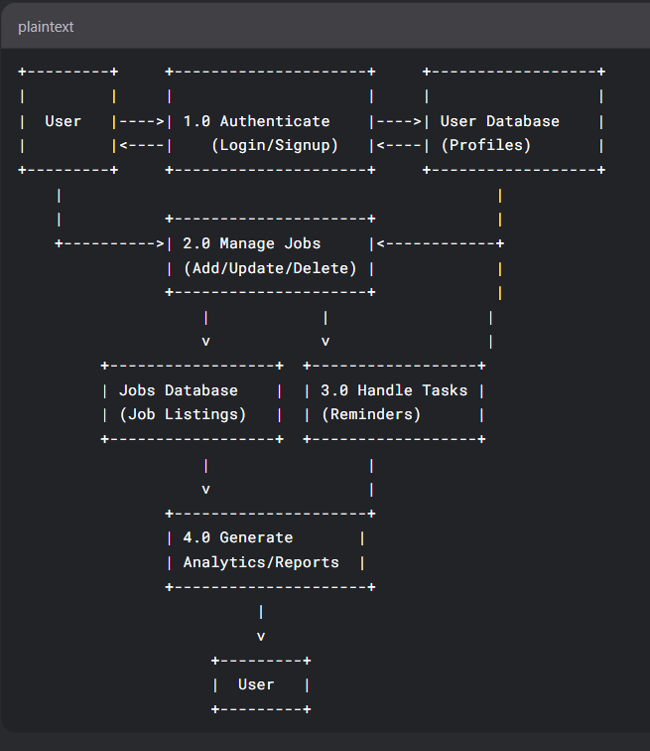

# GitHub Link

* ³<https://github.com/Yash-36-p/Ca.git>

# Appendices

## Appendix 1: Screenshots

1. **Login Page**

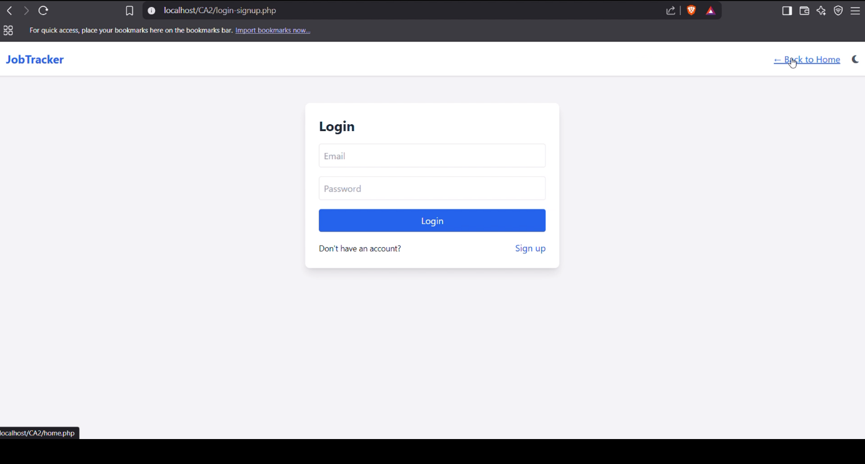

1. **Home Page**

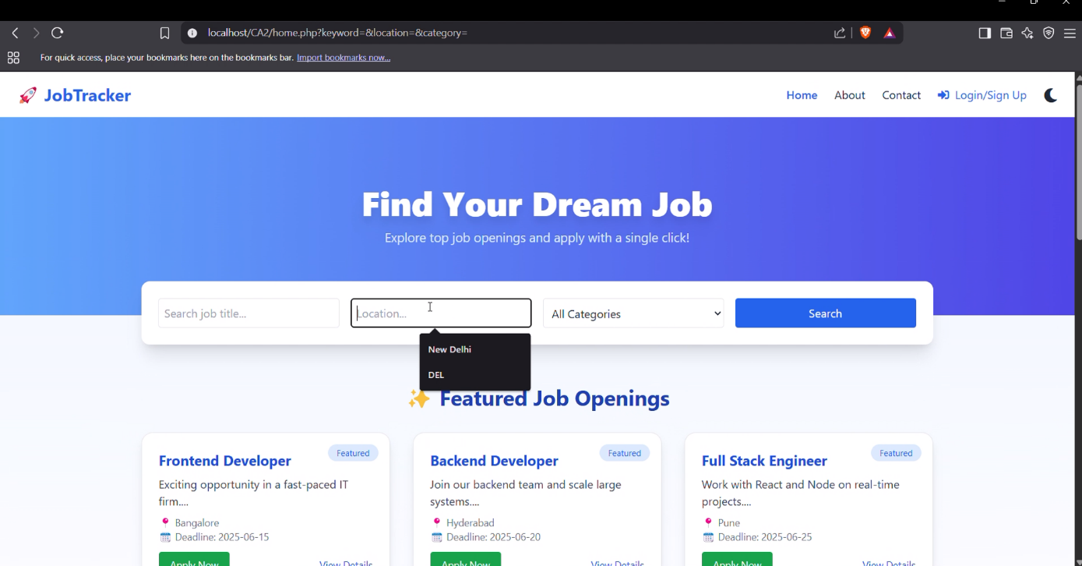

1. **User Profile**

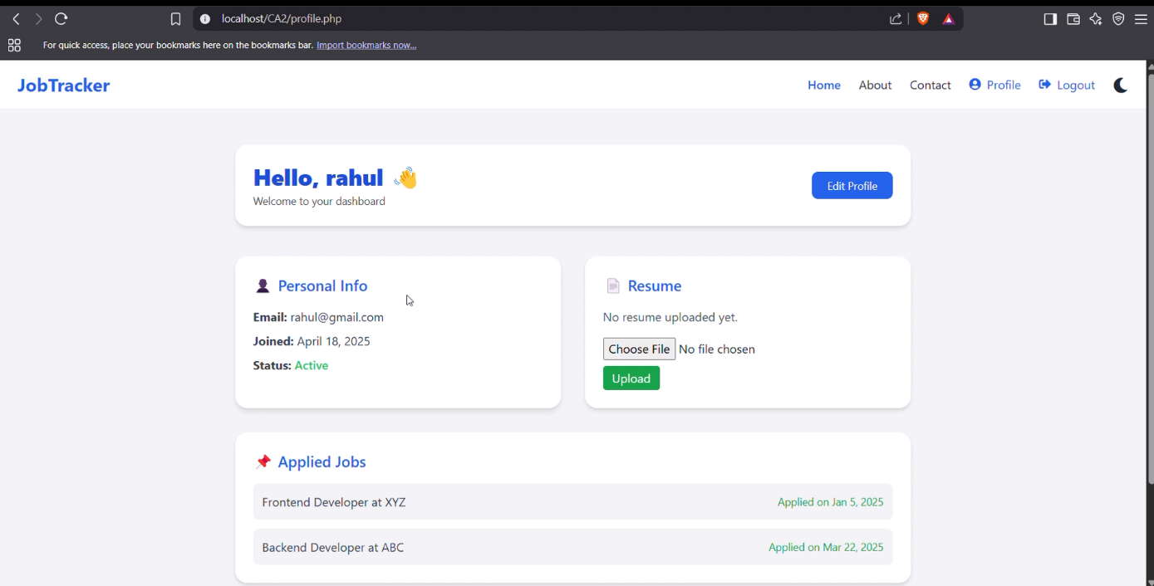

1. **Admin Dashboard & Data Analysis**

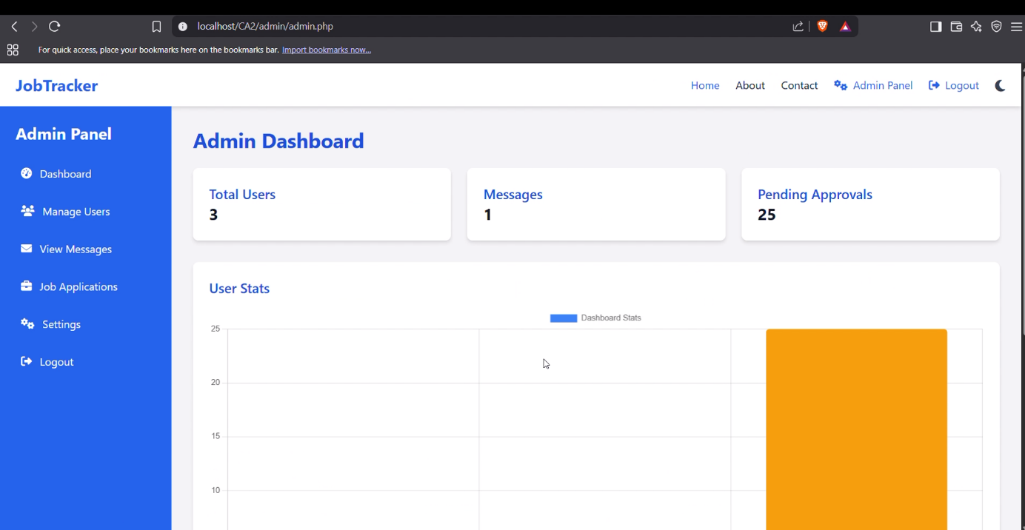

1. **User Management**

